SWE316
Assignment 2
12/12/2022
Turki Alzahrani
201936550

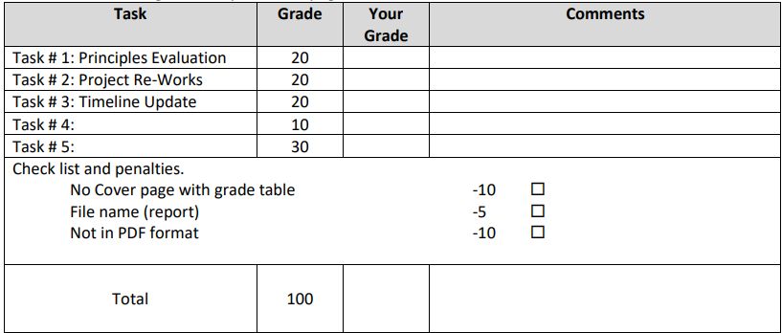

Principles Evaluation

Class | Responsiblty | split
File | Read_data, list_data | Reader , ProjectListbox
GUI | Show the data | TimelineChart,Numberednode,Eventline
Application | Start the application
Project | Use the reader to get the data
Stages | Use the reader to get the data

Class diagram for part B:
